Online Exam Management System

UML Diagrams

*Email Verification*

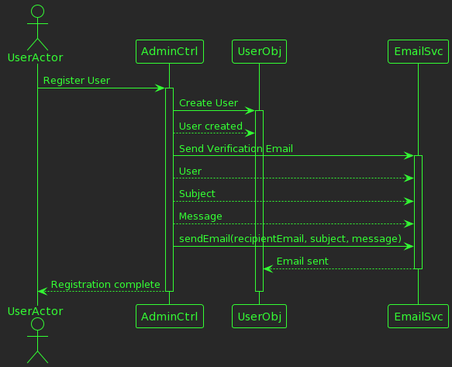

@startuml

!theme crt-green

!define ADMIN_CONTROLLER class AdministratorController [[java:edu.sru.thangiah.controller.AdministratorController]]

!define EMAIL_SERVICE class EmailService [[java:edu.sru.thangiah.service.EmailService]]

!define USER class User [[java:edu.sru.thangiah.model.User]]

actor UserActor

UserActor -> AdminCtrl: Register User

activate AdminCtrl

AdminCtrl -> UserObj: Create User

activate UserObj

AdminCtrl --> UserObj: User created

AdminCtrl -> EmailSvc: Send Verification Email

activate EmailSvc

AdminCtrl --> EmailSvc: User

AdminCtrl --> EmailSvc: Subject

AdminCtrl --> EmailSvc: Message

AdminCtrl -> EmailSvc: sendEmail(recipientEmail, subject, message)

EmailSvc --> UserObj: Email sent

deactivate EmailSvc

AdminCtrl --> UserActor: Registration complete

deactivate UserActor

deactivate AdminCtrl

deactivate UserObj

@enduml

**Excel Import**

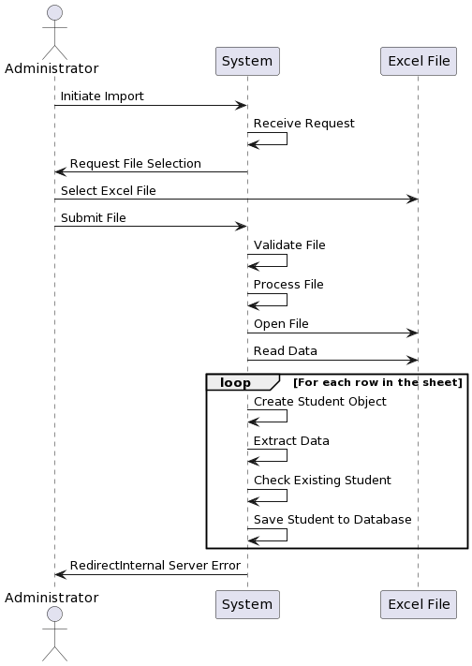

actor Administrator as Admin

participant System

participant "Excel File" as ExcelFile

Admin -> System: Initiate Import

System -> System: Receive Request

System -> Admin: Request File Selection

Admin -> ExcelFile: Select Excel File

Admin -> System: Submit File

System -> System: Validate File

System -> System: Process File

System -> ExcelFile: Open File

System -> ExcelFile: Read Data

loop For each row in the sheet

System -> System: Create Student Object

System -> System: Extract Data

System -> System: Check Existing Student

System -> System: Save Student to Database

end

System -> Admin: RedirectInternal Server Error

**Excel Export**

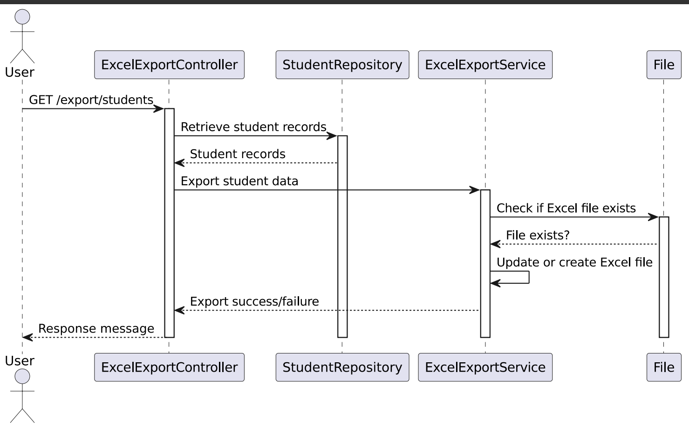

Class Diagram UserSeviceImpl:

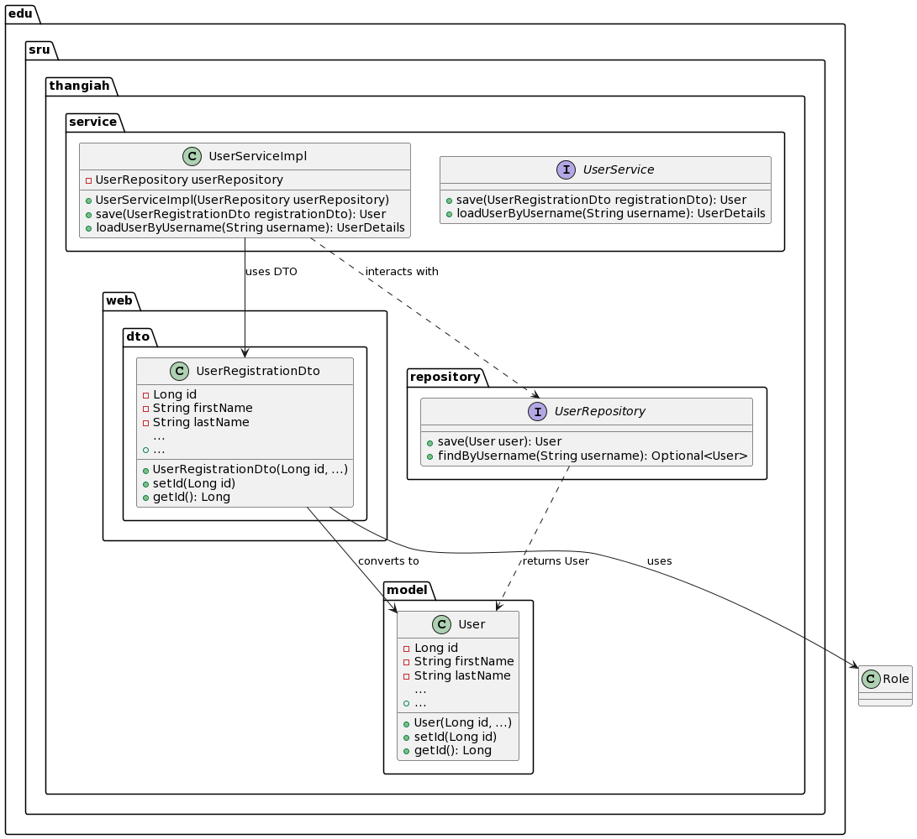

@startuml

package "edu.sru.thangiah.web.dto" {

class UserRegistrationDto {

- Long id

- String firstName

- String lastName

...

+ UserRegistrationDto(Long id, ...)

+ setId(Long id)

+ getId(): Long

+ ...

}

}

package "edu.sru.thangiah.service" {

interface UserService {

+ save(UserRegistrationDto registrationDto): User

+ loadUserByUsername(String username): UserDetails

}

class UserServiceImpl {

- UserRepository userRepository

+ UserServiceImpl(UserRepository userRepository)

+ save(UserRegistrationDto registrationDto): User

+ loadUserByUsername(String username): UserDetails

}

}

package "edu.sru.thangiah.repository" {

interface UserRepository {

+ save(User user): User

+ findByUsername(String username): Optional<User>

}

}

package "edu.sru.thangiah.model" {

class User {

- Long id

- String firstName

- String lastName

...

+ User(Long id, ...)

+ setId(Long id)

+ getId(): Long

+ ...

}

}

UserRegistrationDto --> User : converts to

UserServiceImpl --> UserRegistrationDto : uses DTO

UserServiceImpl ..> UserRepository : interacts with

UserRepository ..> User : returns User

UserRegistrationDto --> Role : uses

@enduml